Microsoft SLK Migration Guide

Contents

1 Summary 2
1.1 Goals 2
1.2 Intended Audience 2
1.3 Common Abbreviations 2
1.4 Class Server 3.0 to SLK 2
1.5 Licensed Learning Resources 2
1.5.1 Multiple Learning Resources 3
1.5.2 Curriculum Standards 3
1.5.3 File System Files 3
1.5.4 LR Metadata Promotion 3
1.6 Guide Contents 3
2 Migration Process Overview 3
2.1 Introduction 3
3 Preparations for Migration 4
3.1 Provisioning Data 4
3.1.1 Pre-requisitions 4
3.2 Limitations 4
4 Package Analyser 4
4.1 Class Server 4.0 Database analysis of assigned learning resources 4
4.2 Reporting of Multi-LR and Licensed LRs 5
5 Site Builder 5
5.1 Before using the tool 5
5.2 Running SiteBuilder 5
6 Validating Migration 8
7 Appendix 8
7.1 PackageAnalyser.exe.config File Format 8
7.2 References 8

Summary
This guide outlines the procedure to follow when migrating from Microsoft Class Server 4.0 to Microsoft SharePoint Learning Kit (SLK)

Goals
The goal of this project and this guide is to assist users of Class Server 4.0 to move their data to an SLK site in a consistent and meaningful manner. Providing access to historical Class Server 4.0 data from their new SLK site.

Intended Audience
This guide is intended for individuals who have administrative knowledge of the following:
- Microsoft Class Server 4.0
- Microsoft Windows SharePoint Services 3.0
- Microsoft SLK
- Microsoft Active Directory
- and XML file manipulation

Common Abbreviations
Term | Meaning
SLK | Microsoft SharePoint Learning Kit
CS3/4 | Class Server 3.0/4.0
AD | Microsoft Active Directory
WSS3 | Microsoft Windows SharePoint Services 3.0
LR | Learning Resource
DocLib | Microsoft SharePoint Document Library

Class Server 3.0 to SLK
The migration path from Class Server 3.0 to SLK will be beyond the scope of this project, however it should follow the ‘Class Server 4.0 with no SharePoint” migration path.
The recommended procedure for migrating from Class Server 3.0 to SLK would be to first upgrade from Class Server 3.0 to Class Server 4.0 and then follow this guide to migrate the data to SLK.

Licensed Learning Resources
CS4 Licensed LRs are not supported in SLK. Customers with licensed LR content should contact the content provider to receive an un-licensed copy of their LRs for continued use in the SLK environment.

Multiple Learning Resources
LRs can contain other LRs to facilitate distribution, however the SLK does not support this feature.

Curriculum Standards
Curriculum Standards are not supported in SLK and the data will not be displayed.

File System Files
CS4 has LR files stored on the file system in the “Server Data Folder”, path defined in the CS4 configuration. These files will be moved to a SLK Document Library (DocLib). The user will be requested to provide the path to the desired DocLib or a default DocLib will be created.

LR Metadata Promotion
Metadata promoted adds metadata from a LR’s index.xml or imsmanifest.xml to SharePoint DocLib columns. The CS4 LRUpload tool did this in CS4 and when LRs are uploaded to the DocLibs this meta data will be promoted also.

Guide Contents
This Guide contains two tools:
- PackageAnalyser – a tool for migrating learning resources used in Class Server.
- SiteBuilder – a tool for transferring Class Server 4 classes, groups, users and assignments into SLK.

Migration Process Overview

Introduction
Data migration from Class Server 4.0 to SLK involves a number of stages.
- Transfer of Class Server 4 classes, groups and users to SLK, using SiteBuilder application.
- Transfer of learning resources (manual process with help of PackageAnalyser application).
- Transfer of user assignments and grades (using PackageAnalyser and SiteBuilder applications).
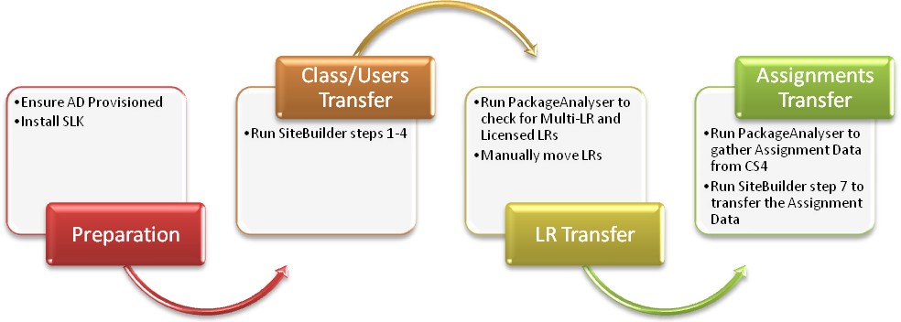

Preparations for Migration

Provisioning Data

Pre-requisitions
Unless configured differently, Office SharePoint Server 2007 automatically detects the domain controller and imports the user information from the Active Directory directory service.
Ref: http://msdn2.microsoft.com/en-us/library/ms545122.aspx

Limitations
- Transfers one school at a time.
- Does not transfer user answers and attachments. Please make sure all submitted papers in Class Server 4 are graded prior to moving to SLK

Package Analyser
Package Analyser uses a configuration file “PackageAnalyser.exe.config” to set the application settings. These settings allow the Package Analyser to perform two functions as outlined below.

Class Server 4.0 Database analysis of assigned learning resources
Set IsSchoolActivityPath to True in PackageAnalyser.exe.config to run application in this mode.
The tool analyses learning packages for assignments stored in Class Server 4 database.
Class Server 4 database does not store information about what learning package is used in any given assignment. We need this information for correctly transferring assignments to SLK.
Path parameter in PackageAnalyser.exe.config should be set to the activity path for the school.
Please make sure the SchoolDBConnectionString parameter is also set to specify connection string to the relevant school.
Package Analyser recursively searches the path given to find all assignments and determine which learning package was used.
This information then gets stored in the Class Server 4 database in AssignmentPackageTransfer table.

Reporting of Multi-LR and Licensed LRs
Set IsSchoolActivityPath to False in PackageAnalyser.exe.config to run application in this mode.
In this case SchoolDBConnectionString parameter is not being used.
The tool is used for reporting purpose only.
The tool recursively searches the given folder for learning resources in .LRM,.IMS and .ZIP formats, as well as unpackaged resources.
For every learning resource found it reports its package identifier. It reports if the recourse is Multiple LR or if it's licensed (in both cases these resources cannot be used in SLK).

Site Builder
SiteBuilder is the tool for transferring Class Server 4 classes, groups, users and assignments into SLK.

Before using the tool
- Apply the CS4script.sql script to the Class Server 4 database you're going to move.
- Ensure the new SLK server is ready to receive the data, e.g. install SharePoint Services v3, and SharePoint Learning kit.
- Create a new SharePoint v3 site for SLK Document Library. Configure the Document Library Web Site for SLK, and activate SLK feature on it (see SLK installation guide for further instructions).
- Create a new SharePoint v3 site for the school you're moving from Class Server 4.
- Configure the school site for SLK.
- Make sure all your Class Server 4 users hold domain or local machine accounts, e.g. can be handled by SharePoint.

Running SiteBuilder
- Click on Step 1 and fill in the transfer parameters.
Note: the Active Directory path is auto-created based on your local machine domain membership, you may need to adjust it to allow all the user accounts from your Class Server 4 installation to be found.
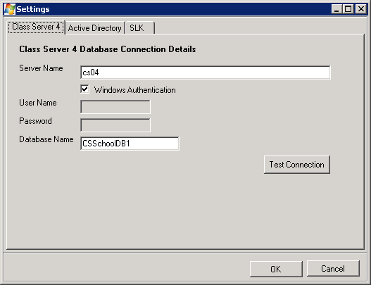
- Click on Step 2. The application will retrieve all the users from the school database and attempt looking them up using Active Directory Searcher. ADCheck.log file will contain the verification results. Please check the log file and ensure all the users you need to transfer were successfully found. If some users were not found please correct their user accounts in Class Server 4, e.g. add the correct domain name, etc.
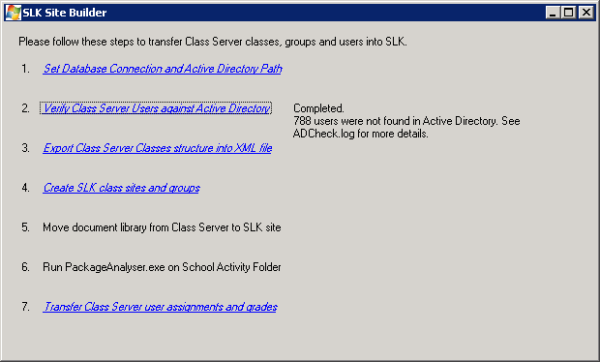
- Click on Step 3. The application will read Class Server 4 database and write your classes structure into Classes.xml file. You can modify Classes.xml file to exclude some classes/groups/users from being transferred, or change the classes/groups web names.
- Click on step 4. The application will read the Classes.xml file and will create sub sites for each class; SharePoint group for every Class Server 4 group and will give users appropriate rights to the document library and the class websites.
- Move document library from Class Server 4 to SLK SharePoint. SharePoint 2 doc library can be dealt with as a network resource.
  - A SharePoint site can be registered through Network resources wizard and then you can just open it, open a document library as a folder, copy documents from there as usual files and then paste them into any local folder on your Server.
  - After copying, run the PackageAnalyser tool on this folder to determine if some learning resources are licensed or contain multiple LRs.
  - Mass import files from this folder into your new SharePoint v3 document library.
- Run PackageAnalyser on the Class Server 4 Server, setting Path to School Activity Folder and IsSchoolActivityPath to True. This will import information about packages used by Class Server 4 assignments. It is important to have all learning packages used in these assignments imported into SLK Learning Resources Library before proceeding.
- Click on step 7. The application will read Classes.xml and for each class with Transfer property set to True will get assignments; grades and teacher comments from Class Server 4 database and creates same assignments; grades and comments in SLK.

Validating Migration

Appendix

PackageAnalyser.exe.config File Format
<?xml version="1.0" encoding="utf-8" ?>
<configuration>
<configSections>
<sectionGroup name="applicationSettings" type="System.Configuration.ApplicationSettingsGroup, System, Version=2.0.0.0, Culture=neutral, PublicKeyToken=b77a5c561934e089" >
<section name="PackageAnalyser.App" type="System.Configuration.ClientSettingsSection, System, Version=2.0.0.0, Culture=neutral, PublicKeyToken=b77a5c561934e089" requirePermission="false" />
</sectionGroup>
</configSections>
<applicationSettings>
<PackageAnalyser.App>
<setting name="Path" serializeAs="String">
<value />
</setting>
<setting name="SchoolDBConnectionString" serializeAs="String">
<value />
</setting>
<setting name="IsSchoolActivityPath" serializeAs="String">
<value>True</value>
</setting>
</PackageAnalyser.App>
</applicationSettings>
</configuration>

References
WSS v3 SDK http://msdn2.microsoft.com/en-us/library/aa155170.aspx
“How to provision a file” WSS v3 http://msdn2.microsoft.com/en-us/library/ms441170.aspx
“How to: Upload a file to a SharePoint Site from a local folder” WSS v3 http://msdn2.microsoft.com/en-us/library/ms454491.aspx
“How to: access, copy and move files” WSS v3 http://msdn2.microsoft.com/en-us/library/ms470176.aspx
“How to: Create or Delete a Site or Site Collection” WSS v3 http://msdn2.microsoft.com/en-us/library/ms448720.aspx

